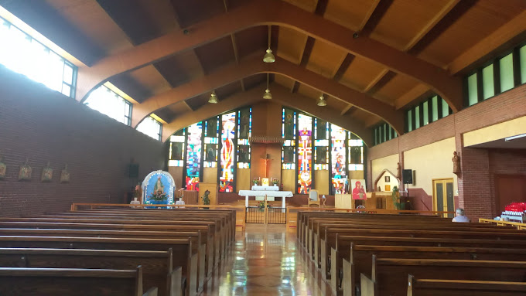
940 Monastery Road
Monastery, NS
B0H 1W0
Tel. 902-232-2214
Chaplains: Fr. Frank Pellerin, A.S.C.
Fr. Albert MacPherson, O.S.A.
Sunday, April 7, 2024
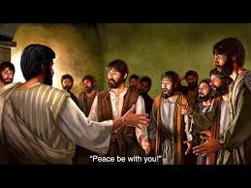

Second Sunday of Easter
Divine Mercy Sunday

First Reading – Acts 4.32-35 In this passage we read that all the followers of Jesus, not just the apostles, were so enthusiastic about this “new way” of life that they lived in communities in order to share everything, both material and spiritual. This way they could help in nourishing and sharing their newfound spiritual life in Christ with each other. Because of this joy many others came to believe and "the Lord added to their number."

Second Reading – 1 John 5.1-6 – This is a brief summary of the Christian life then and now. We should not think of Christ's Resurrection as something that happened 2000 years ago. Rather, we should be thinking about it on a daily basis as something that God does for us in every Mass that is offered on our behalf--not just those we attend, but all Masses. They are the greatest prayers of thanksgiving that one could offer for this sublime act of divine love.

Gospel – John 20.19-31 – Put yourself in this scene. It is the night of the Resurrection and Jesus appears in all His divine Glory before the apostles. Can you imagine the joy after the shock subsides? The apostles must have been bouncing all over the room. Then later, Thomas, who wasn't there, throws cold water on that first event when he learns about it by refusing to believe. It takes another appearance of Jesus to convince Thomas who then utters that great phrase of humility, "My Lord and my God!"
Our Lady of Grace Chapel Schedule:
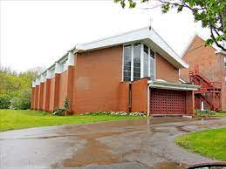
Chapel is open from 8:30 A.M to 5:00 P.M., daily.
Weekday Masses: Monday to Friday – 9:30 A.M.
Saturday Mass: 10:00 A.M.
Sunday Mass: 10:00 A.M
Sacrament of Reconciliation (Confession) after Weekday Masses and devotions, by appointment, call 902-232-2214 or if a priest is in the Monastery, we will gladly hear your confession (Please ring the doorbell, near the confessional, on the right-hand side of the Chapel near the confessional, and if a priest is in residence, he will come to the Chapel within a few minutes).

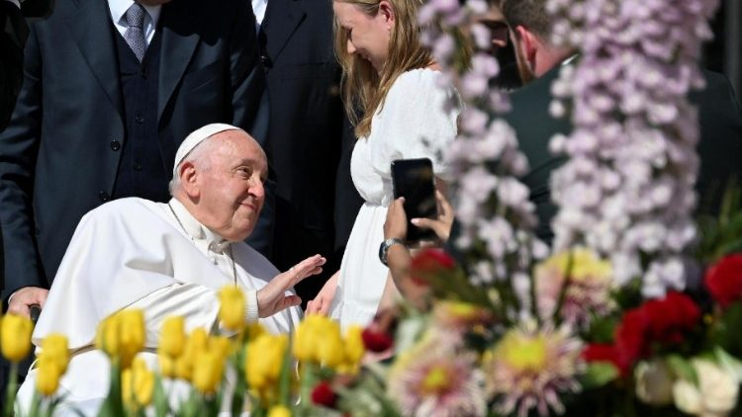

Pope Francis’ Prayer Intention for April 2024 – For the role of women: We pray that the dignity and immense value of women be recognised in every culture, and for the end of discrimination that they experience in different parts of the world.

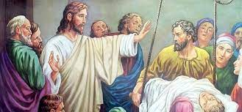
Augustinian Healing Ministries
There will be a Healing Mass on Saturday, April 27, 2024, at 2:00 P.M. (instead of the usual time of 7:00 P.M.), in Our Lady of Grace Monastery Chapel, celebrated by Father Albert Mac Pherson, O.S.A. There will anointing with blessed oil and prayers for healing of body, mind and spirit.

Masses: Dates, Times, Feasts, Intentions
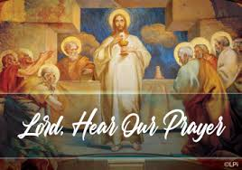
Sunday,7th, 10:00 A.M. – Second Sunday in Ordinary Time – Acts 4.32-35, 1 John 5.1-6, John 20.19-31, - Intention: Pro Populo (For the People)
1:00 P.M. – 1:45 P.M
2:00 - 3:00 P.M. – Exposition of the Blessed Sacrament,
Divine Mercy Prayers, Psalms and Meditation Time
3:00 – 4:00 P.M. – Divine Mercy Chaplet, Prayers, Psalms, Meditation Time, and Benediction
Monday, 8th, 9:30 A.M – Solemnity of the Annunciation of the Lord – Isaiah 7.10-14 - 8.10, Hebrews 10.4-10, Luke 1.26-38 – Intention: For the Holy Souls in Purgatory and the deceased members of F.O.S.S (Those who have prayed for the Holy Souls in Purgatory) – Requested by Rose Turvey
Tuesday, 9th, 9:30 A.M.– Acts 4.32-37, John 3.7-15
Wednesday, 10th, 9:30 A.M. – Acts 5.17-26, John 3.16-21
Thursday 11th, 9:30 A.M. – Memorial of Saint Stanislaus, Bishop, Martyr – Acts 5.27-33, Jon 3.31-36
Friday, 12th, 9:30 A.M. – Acts 5.34-42, John 6.1-15
Saturday, 13th, 10:00 A.M. – Saint Martin I, Pope, Martyr – Acts 6.1-7, John 6.16-21
Sunday, 14th, - 10:00 A.M. – Third Sunday of Easter – Acts 3.13-15, 17-19,1John 2.1-5, Luke 24.35-48– Intentions: Pro Populo (For the People)
2:00 P.M. – Exposition of the Blessed Sacrament, Divine Mercy Prayers, Psalms and Meditation Time
3:00 P.M. – Divine Mercy Chaplet, Prayers, Psalms, Meditation Time and Benediction

Today, is Divine Mercy Sunday. So, What is Divine Mercy Sunday?
In a series of revelations to St. Maria Faustina Kowalska in the 1930s, our Lord called for a special feast day to be celebrated on the Sunday after Easter. Today, we know that feast as Divine Mercy Sunday, named by Pope St. John Paul II at the canonization of St. Faustina on April 30, 2000.
The Lord expressed His will with regard to this feast in His very first revelation to St. Faustina. The most comprehensive revelation can be found in her Diary entry 699:
My daughter, tell the whole world about My inconceivable mercy. I desire that the Feast of Mercy be a refuge and a shelter for all souls, and especially for poor sinners. On that day the very depths of My tender mercy are open. I pour out a whole ocean of graces upon those souls who approach the fount of My mercy. The soul that will go to Confession and receive Holy Communion shall obtain complete forgiveness of sins and punishment. On that day are opened all the divine floodgates through which graces flow. Let no soul fear to draw near to Me, even though its sins be as scarlet. My mercy is so great that no mind, be it of man or of angel, will be able to fathom it throughout all eternity. Everything that exists has come from the very depths of My most tender mercy. Every soul in its relation to Me will contemplate My love and mercy throughout eternity. The Feast of Mercy emerged from My very depths of tenderness. It is My desire that it be solemnly celebrated on the first Sunday after Easter. Mankind will not have peace until it turns to the Fount of My mercy.
In all, St. Faustina recorded 14 revelations from Jesus concerning His desire for this feast.
Nevertheless, Divine Mercy Sunday is NOT a feast based solely on St. Faustina's revelations. Indeed, it is not primarily about St. Faustina — nor is it altogether a new feast. The Second Sunday of Easter was already a solemnity as the Octave Day of Easter. The title "Divine Mercy Sunday" does, however, highlight the meaning of the day.

The Divine Mercy Image
Veneration of the Image on Divine Mercy Sunday
The Image of Jesus, The Divine Mercy, is to be venerated* on Divine Mercy Sunday. It is to be given a place of honor in our churches and homes on this Sunday. Our Lord appeared to St. Faustina and then directed her to have this appearance of Himself as the Merciful Savior painted and then venerated publicly. He told her, I want the Image to be solemnly blessed on the first Sunday after Easter, and I want it to be venerated publicly so that every soul may know about it (Diary of St. Faustina, 341).
In the Image, our Risen Savior has pale and red rays streaming from His side. These rays symbolize the Blood and Water that flowed from His side while He was on the cross. But, in His appearance to St. Faustina, they had been transformed into glorious rays, revealing a fount of healing graces for sinners who will turn to Him with trust. That is why the Image always bears the inscription: "Jesus, I trust in You!"
In our churches and homes, we can venerate the Image of Jesus, The Divine Mercy, by gazing upon it in prayer and adoration. As signs of our love for Jesus, we can place candles and flowers before the Image. First and foremost, as we gaze upon our Merciful Savior in prayer, we can decide to trust in Him and to perform works of mercy — responding to the call to be merciful just as He has shown mercy to us.
* To "venerate" a sacred image simply means to perform some act or make some gesture of deep religious respect toward it because of the person whom it represents.

From the Diary of Saint Sister Faustina #88

+ During adoration I felt God close to me. A moment later I saw Jesus and Mary. At the sight of them I was filled with joy, and I asked the Lord, "What is Your will, Jesus, concerning the matter about which my confessor told me to ask You?" Jesus replied, It is My will that he should remain here and that he should not take the initiative of dispensing himself. I asked Jesus whether the inscription could be: "Christ, King of Mercy." He answered, “I am King of Mercy”, but He did not say "Christ." I desire that this image be displayed in public on the first Sunday after Easter. That Sunday is the Feast of Mercy. I desire that this image be displayed in public on the first Sunday after Easter. That Sunday is the Feast of Mercy. Through the Word Incarnate, I make known the bottomless depth of My mercy.

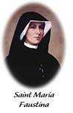
Saint Maria Faustina Kowalska - The Humble Instrument
Sister Faustina was a young, uneducated nun in a convent of the Congregation of Sisters of Our Lady of Mercy in Poland during the 1930s. She came from a poor family that struggled during the years of World War I. She had only three years of simple education, so hers were the humblest tasks in the convent, usually in the kitchen or garden. However, she received extraordinary revelations — or messages — from our Lord Jesus. Jesus asked Sr. Faustina to record these experiences, which she compiled into notebooks. These notebooks are known today as the Diary of Saint Maria Faustina Kowalska, and the words contained within are God's loving message of Divine Mercy.
Though the Divine Mercy message is not new to the teachings of the Church, Sr. Faustina's Diary sparked a great movement, and a strong and significant focus on the mercy of Christ. Saint John Paul II canonized Sr. Faustina in 2000 making her the "first saint of the new millennium." Speaking of Sr. Faustina and the importance of the message contained in her Diary, the Pope called her "the great apostle of Divine Mercy in our time."
Today, we continue to rely on St. Faustina as a constant reminder of the message to trust in Jesus' endless mercy, and to live life mercifully toward others. We also turn to her in prayer and request her intercession to our merciful Savior on our behalf. At the National Shrine of The Divine Mercy in Stockbridge, Massachusetts, we include the following in our 3 o'clock prayers:
Saint Faustina,
You told us that your mission would continue after your death and that you would not forget us. Our Lord also granted you a great privilege, telling you to "distribute graces as you will, to whom you will, and when you will." Relying on this, we ask your intercession for the graces we need, especially for the intentions just mentioned. Help us, above all, to trust in Jesus as you did and thus to glorify His mercy every moment of our lives. Amen

