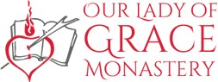
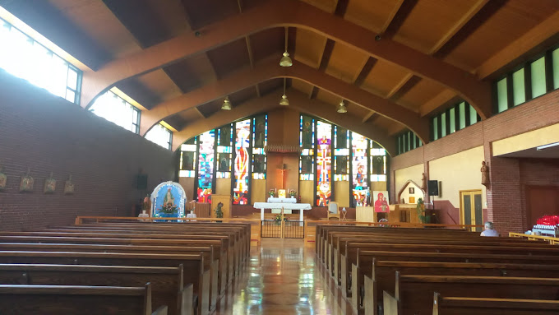
940 Monastery Road
Monastery, NS
B0H 1W0
Tel. 902-232-2214
Chaplains: Fr. Frank Pellerin, A.S.C.
Fr. Albert MacPherson, O.S.A.
Sunday, April 21, 2024
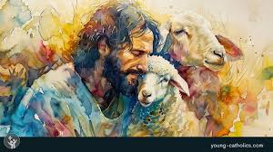

Fourth Sunday of Easter

First Reading – Acts of the Apostles 4:8-12
Peter announces an act of healing in the name of Jesus Christ.

Second Reading – 1 John 2.1-5 – Those who know God keep his commandments.

Gospel – John 10:11-18
Jesus says that he is the good shepherd who knows his sheep.

Our Lady of Grace Chapel Schedule:
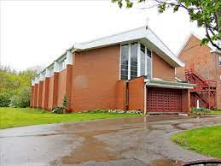
Chapel is open from 8:30 A.M to 5:00 P.M., daily.
Weekday Masses: Monday to Friday – 9:30 A.M.
Saturday Mass: 10:00 A.M.
Sunday Mass: 10:00 A.M
Sacrament of Reconciliation (Confession) after Weekday Masses and devotions, by appointment, call 902-232-2214 or if a priest is in the Monastery, we will gladly hear your confession (Please ring the doorbell, near the confessional, on the right-hand side of the Chapel near the confessional, and if a priest is in residence, he will come to the Chapel within a few minutes).

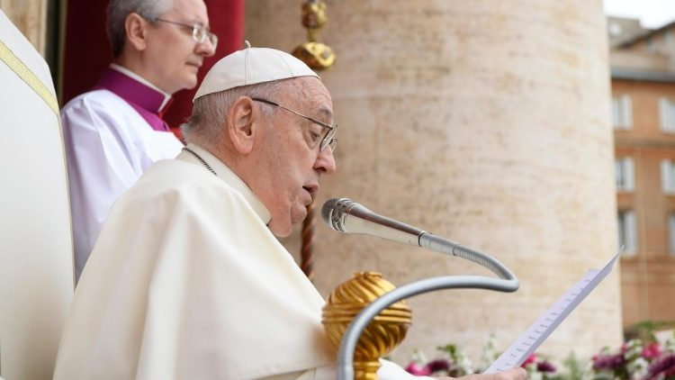
Pope Francis’ Prayer Intention for April 2024 – For the role of women: We pray that the dignity and immense value of women be recognised in every culture, and for the end of discrimination that they experience in different parts of the world.

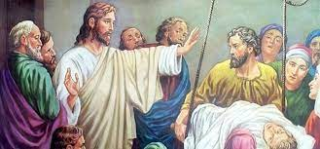
Augustinian Healing Ministries
There will be a Healing Mass on Saturday, April 27, 2024, at 2:00 P.M. (instead of the usual time of 7:00 P.M.), in Our Lady of Grace Monastery Chapel, celebrated by Father Albert Mac Pherson, O.S.A. There will anointing with blessed oil and prayers for healing of body, mind and spirit.

Masses: Dates, Times, Feasts, Intentions
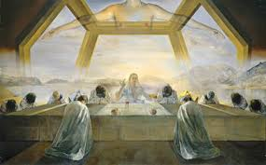
Sunday,21st, 10:00 A.M. – Second Sunday in Ordinary Time – Acts 4.7-12, 1 John 3.1-2, John 10.11-18, - Intention: Pro Populo (For the People)
2:00 - 3:00 P.M. – Exposition of the Blessed Sacrament,
Divine Mercy Prayers, Psalms and Meditation Time
3:00 – 4:00 P.M. – Divine Mercy Chaplet, Prayers, Psalms, Meditation Time, and Benediction
Monday, 22nd, 9:30 A.M – Acts 11.1-18, John 10.1-10
Tuesday, 23rd, 9:30 A.M.– Acts 11.19-26, John 10.22-30
Wednesday, 24th, 9:30 A.M. – Conversion of Saint Augustine – Romans 13.11-14, Luke 15.11-24
Thursday 25th, 9:30 A.M. – Saint Mark, Evangelist -1 Peter 5.5-14, Mark 16.15-20
Friday, 26th, 9:30 A.M. – Our Mother of Good Counsel - Acts 1.12-14 -2.1-4, John 14. 1-6
Saturday, 27th, 10:00 A.M. – Acts 13.44-52, John 2.1-11
Sunday, 28th, 10:00 A.M. – Fifth Sunday of Easter – Acts 9.26-31, 1John 3.18-24, John 15.1-8– Intentions: Pro Populo (For the People)
2:00 P.M. – Exposition of the Blessed Sacrament, Divine Mercy Prayers, Psalms and Meditation Time
3:00 P.M. – Divine Mercy Chaplet, Prayers, Psalms, Meditation Time and Benediction
Addition to our Calendar for the Two Augustinian Feasts
Wednesday, April 24,2024, 9:00 A.M. – Feast of the Conversion of Saint Augustine - Office of Readings from the Proper Offices for The Augustinian Saints and Blesseds
Friday, April 26,2024, 9:00 A.M. – Feast of Mary Our Mother of Good Counsel – Office of Readings from the Proper Offices for the Augustinian Saints and Blesseds
Reflection on Sunday’s Gospel, John 10. 1-10
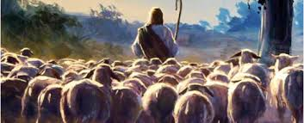
The Fourth Sunday of Easter is also called Good Shepherd Sunday. In each of the three lectionary cycles, our Gospel is taken from the 10th chapter of the Gospel of John. In Cycle B hear being proclaimed the middle verses of this chapter. But as we hear and listen, we must also have an “ear’ for the greater context of John’s Gospel or we will miss the radical nature of the statement Jesus makes when he declares himself to be the Good Shepherd.
This chapter of John’s Gospel follows Jesus’ healing of the man born blind and the rejection of this miracle by the Jewish leaders who question Jesus’ authority to heal. Jesus responds to this challenge by calling himself the Good Shepherd. He is criticizing the leadership of the Pharisees and the other Jewish leaders. The Pharisees and other Jewish leaders are so angry that they attempt to stone and arrest Jesus (see John 10:31-39). And, this controversy with the religious leaders will continue until Jesus’ death.
In the portion of the chapter that we hear proclaimed today, Jesus describes his relationship with his followers as similar to the relationship between a good shepherd and his sheep. As a good shepherd will risk and lay down his life in order to protect his sheep, Jesus willingly sacrifices himself for the sake of his sheep. Jesus contrasts the actions of the good shepherd with the actions of the hired shepherd who abandons the sheep in the face of danger. In the verses following Jesus' teaching, we learn that the Pharisees and the other religious leaders understand that Jesus is referring to them when he describes the hired shepherds.
The concern of a good shepherd for his sheep is part of the shepherd’s job. Jesus says, however, that the actions of the good shepherd are based upon the relationship that develops between the shepherd and the sheep. This is at the heart of the difference between the good shepherd and the hired shepherd. The good shepherd knows the sheep and therefore acts out of love. For the Good Shepherd, this is never simply part of a job; this love-in-action is integral to his identity.
As with so much of John’s Gospel, one hears in this passage John’s particular focus on Christology. As the sheep are known by the Good Shepherd, the Father knows Jesus and Jesus knows the Father. There is an essential unity between the Father and the Son. The freedom with which Jesus acts when he lays down his life is rooted in the unity that he shares with his Father.
In this context, Jesus also refers to others with whom he shares a relationship. By this reference, John probably understands the eventual inclusion of the Gentiles in the Christian community. Our modern ears hear this as a reference to Christian unity. The work of ecumenism is to restore unity among all Christians so that we form one flock under one shepherd, as God desires.

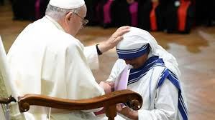
World Day of Prayer for Vocations, SUNDAY,APRIL 21, 2024

Today the Church throughout the world prays for vocations. Will you make a special effort to ask the Lord for vocations to the priesthood and religious life? Pray for the priests who have ministered to you throughout your life, both living and dead. Encourage your children, grandchildren, or other young people to consider a vocation as a priest or religious brother or sister. Pray a rosary for more young men and women in our diocese to respond to God’s call.
Pray for Vocations!
As Catholics, we firmly believe that God has a plan for our lives! He calls some to marriage, some to the priesthood, and others to religious life or to live as generous single people. Fully living our own vocations—and teaching young people how to discern God’s call—is a serious duty, but also a joyful one. During this week, please encourage the young people in your life—children, grandchildren, students, and friends—to be open if God calls them to priesthood or religious life.
Everyone Has a Divine Vocation
“Jesus has a specific task in life for each and every one of us. Each one of us is hand-picked, called by name by Jesus! There is no one among us who does not have a divine vocation! Some are called audibly by God, but the usual kind of call is internal, through the inner working of the Spirit.” ~Homily by Pope Saint John Paul II

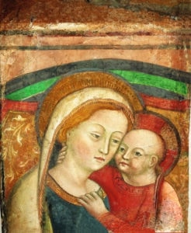
April 26th Feast of Our Mother of Good Counsel -
We honor Mary in the Church under many titles. Today’s celebration is one particularly dear to Augustinians throughout the world. The tender image of mother and child is at one and the same time so very human and so illustrative of a deep spiritual truth. Mary, mother of her infant son, is also his first and most faithful disciple. He who is her Lord embraces her affectionately as she, his mother, receives from him words of wisdom and counsel.
Augustinian devotion to Mary under the title of Our Mother of Good Counsel has its origin in the hill-town church of Genazzano, Italy, where the Augustinians have been located since the 13th Century. Originally, their monastery was situated outside the town, but a century they later were invited to take charge of the parish church of Our Mother of Good Counsel in the town-center. When the friars decided to renovate and enlarge the church there occurred an event that came to be considered miraculous, and which drew the attention of great crowds of people. On April 25, 1467, as a side wall was being repaired and a marble figure of the Madonna was removed, there appeared, where the figure had hung, an image of Mary and the Child Jesus. From that moment the title of the church was applied also to the image. According to an old tradition, this very icon, venerated in Albania under the name Our Lady of Scutari or Our Lady of the Albanians, is said to have suddenly disappeared from a church as Albania was being invaded by infidels. Legend says that it floated from the church and was followed by two Albanian men until they reached Genazzano and recognized the image as their own. The news of the “appearance” of the image, coupled with the story of the Albanians, has caused the church, from that time, to be the destination of many pilgrims, including several popes, saints and blesseds. Pope John XXIII was a pilgrim to the shrine on the eve of the Second Vatican Council, and Pope John Paul II visited it before going to Albania to re-establish the hierarchy there following the collapse of communism. Leo XIII had declared the church a Minor Basilica in 1903 and in April of that year introduced the invocation ‘Mother of Good Counsel’ to the Litany of Loreto. Blessed Stephen Bellesini was pastor of this church for nine years until his death in 1840. His venerated remains are preserved in a side chapel of the basilica.
We note the ‘good counsel’ of Mary in several scenes of the Gospel, especially that of Cana, when the mother of Jesus says, “Do whatever he tells you” (Jn. 2, 5). Saint Augustine reminds us that while Mary is blessed for being the mother of Jesus, she is even more blessed for being his disciple. In fact, as the first disciple of her son she presents him to us as our teacher, our way, our truth and our life – even as he was for her.
Feast of Saint Mark, Evangelist
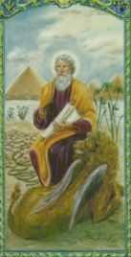
Much of what we know about St. Mark, the author of the Second Gospel, comes largely from the New Testament and early Christian traditions. Mark the Evangelist is believed to be the 'John Mark' referred to in the Acts of the Apostles, the history of the early Church found in the Canon of the New Testament.
He was the son of Mary of Jerusalem (Acts 12:12) whose home became a meeting place for the apostles. He is also the cousin of St. Barnabas (Colossians 4:10), a Levite and a Cypriot.
Mark joined St. Paul and St. Barnabas on their first missionary journey to Antioch in 44 A.D. When the group reached Cyprus, Christian tradition holds that Mark left them and returned to Jerusalem, possibly because he was missing his home (Acts 13:13). This incident may have caused Paul to question whether Mark could be a reliable missionary. This created a disagreement between Paul and Barnabas and led Paul to refuse Mark's accompaniment on their second journey to the churches of Cilicia and the rest of Asia Minor.
However, it can be assumed the troubles between Paul and Mark did not last long, because when Paul was first imprisoned, Mark, who was at the time in Rome with plans of visiting Asia Minor, visited him as one of his trusted companions (Col 4:10).

Mark's hopes to visit Asia Minor were most likely carried out, because during Paul's second captivity and just before his martyrdom, Paul wrote to Timothy at Ephesus advising him to "take Mark and bring him with you [to Rome], for he is profitable to me for the ministry" (2 Timothy 4:11). If Mark returned to Rome at this time, he was probably there when Paul was martyred.
According to Christian tradition, Mark also held a close relationship with St. Peter, who referred to Mark has 'his son' in his letter addressed to a number of churches in Asia Minor (1 Peter 5:13). Clement of Alexandria, Irenaeus and Papias all indicate that Mark was an interpreter for Peter.
Although Papias states Mark had not personally heard the Lord speak firsthand and, like Luke, Mark was not one of the twelve apostles, some believe Mark was likely speaking of himself when he wrote the description of Jesus' arrest in Gethsemani. "Now a young man followed him wearing nothing but a linen cloth about his body. They seized him, but he left the cloth behind and ran off naked" (Mark 14:51-52).
St. Mark lived for years in Alexandria, where he died as a martyr while being dragged through the streets.
Mark's Gospel was probably written between 60 and 70 A.D., and was based upon the teachings of St. Peter. It is believed Mark provided both Luke and Matthew with basic sources for their Gospel's.
He was probably the first bishop of Alexandria, Egypt and the founder of the Church of Alexandria, although he is not mentioned in connection to the city by either Clement of Alexandria nor by Origen.
In 828, relics of St. Mark were stolen from Alexandria and taken to Venice, Italy. There they are enshrined in a beautiful cathedral dedicated to the saint.
St. Mark's symbol is a winged lion. This is believed to be derived from his description of St. John the Baptist, as "a voice of one crying out in the desert" (Mark 1:3). The wings come from Ezekiel's vision of four winged creatures as the evangelists.
He is often depicted as writing or holding his Gospel. He is sometimes shown as a bishop on a throne or as a man helping Venetian sailors.
St. Mark is the patron saint of Venice. His feast day is celebrated on April 25.

