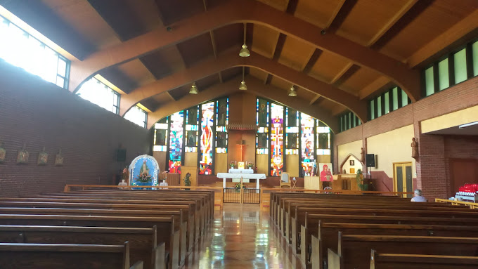 **940 Monastery Road**

**Monastery, NS**

**B0H 1W0**

**Tel. 902-232-2214**

**Chaplains: Fr. Frank Pellerin, A.S.C.**

**Fr. Albert MacPherson, O.S.A.**

**Sunday, April 28, 2024**

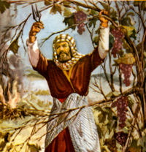

**Fifth Sunday of Easter**

**First Reading –** **Acts of the Apostles 9.26-31 -** Paul is accepted by the apostles at Jerusalem.



**Second Reading –****1 John 3.18-24** – God commands us to believe in Jesus Christ and to love one another.

**Gospel** **–** **John 15.1-8 -** Jesus teaches that he is the vine and that his disciples are the branches.

**Our Lady of Grace Chapel Schedule:**

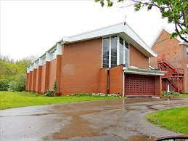Chapel is open from 8:30 A.M to 5:00 P.M., daily.

Weekday Masses: Monday to Friday – 9:30 A.M.

Saturday Mass: 10:00 A.M.

Sunday Mass: 10:00 A.M

Sacrament of Reconciliation (Confession) after Weekday Masses and devotions, by appointment, call 902-232-2214 or if a priest is in the Monastery, we will gladly hear your confession (Please ring the doorbell, near the confessional, on the right-hand side of the Chapel near the confessional, and if a priest is in residence, he will come to the Chapel within a few minutes).

### Pope's messages to seminarians, religious and formators throughout his papacy - YouTubePope Francis’ Prayer Intention for May 2024 – ****For the formation of religious and seminarians**** We pray that religious women and men, and seminarians, grow in their own vocations through their human, pastoral, spiritual and community formation, leading them to be credible witnesses to the Gospel.

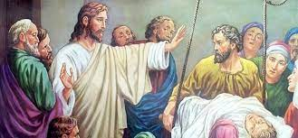**Augustinian Healing Ministries**

**There will be a Healing Mass on Saturday, May 25, 2024, at 2:30 P.M. , in Our Lady of Grace Monastery Chapel, celebrated by Father Albert Mac Pherson, O.S.A. There will be anointing with blessed oil and prayers for healing of body, mind and spirit after the Mass.**

**Masses: Dates, Times, Feasts, Intentions**

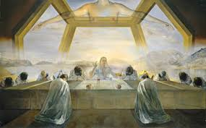

**Sunday,28th, 10:00 A.M. – Fifth Sunday in Ordinary Time** – Acts 9.26-31, 1 John 3.18-24, John 15.1-8, - Intention: Pro Populo (For the People)

**2:00 - 3:00 P.M. –** Exposition of the Blessed Sacrament,

Divine Mercy Prayers, Psalms and Meditation Time

**3:00 – 4:00 P.M.** – Divine Mercy Chaplet, Prayers, Psalms, Meditation Time, and Benediction

**Monday, 29th, 9:30 A.M - Memorial – Saint Catherine of Sienna** – Acts 14.5-18, John 14.21-26 – In Thanksgiving of Healing of Anne Boudreau – Requested by Angie Connors

**Tuesday, 30th, 9:30 A.M. – Sainte Marie de L’Incarnation, Religious** – Acts 14.19-28, John 14.27-31

**Wednesday, May 1st, 9:30 A.M. – Memorial – Saint Joseph, the Worker** –Acts 15.1-6, John 15.1-8

**Thursday 2nd, 9:30 A.M. – Memorial - Saint Athanasius, Bishop, Doctor** -Acts 15.7.21, John 15.9-11

**Friday, 3rd, 9:30 A.M. –** **Feast - Saint Philip and Saint James, Apostles** – 1Corinthians 15.1-8, John 14.6-14

**Saturday, 4th, 10:00 A.M. – Memorial – Blessed Marie-Leonie Paradis, Virgin** – Acts 16.1-10, John 15. 18-21

**Sunday, 5th, 10:00 A.M. – Sixth Sunday of Easter –** Acts 10.25-26, 34-35, 44-48, 1 John 4.7-10 – Intentions: Pro Populo (For the People)

**2:00 P.M. –** Exposition of the Blessed Sacrament, Divine Mercy Prayers, Psalms and Meditation Time

**3:00 P.M. –** Divine Mercy Chaplet, Prayers, Psalms, Meditation Time and Benediction

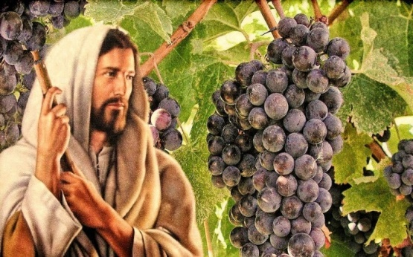**Reflection on Sunday’s Gospel, John 15.1-** Today’s reading from the Gospel of John is part of Jesus’ discourse at the Last Supper. Recall that John tells the story of Jesus’ Last Supper differently from the other Evangelists. In John’s Gospel, the Last Supper begins with Jesus washing his disciples’ feet. Jesus then provides them with a series of instructions. We call this section the Last Supper discourse or Jesus’ farewell discourse. In these chapters of John’s Gospel, Jesus instructs his disciples about the importance of following his example of love and service, about the gift they will receive when Jesus sends them the Holy Spirit, and about their relationship with Jesus and with the world. The Last Supper discourse concludes with Jesus’ prayer for his disciples.

Today’s Gospel reading is taken from middle of the Last Supper discourse. Jesus speaks about his relationship to his disciples. In his metaphor of the vine and the branches, Jesus is referencing the Hebrew Scriptures. In the Hebrew Scriptures, Israel is the vineyard, and Yahweh himself tends the vineyard. One of the primary themes of John’s Gospel is to show Jesus to be the fulfillment of God’s promises to Israel.

In this passage, Jesus teaches his disciples that his relationship with them will not end after his death; he will remain with them always. This unity between Jesus and his disciples is the basis for their ability to continue to do the work that he began. Similarly, Jesus’ presence with us through the Gift of the Holy Spirit enables us to continue the work of love and reconciliation that he began.

Jesus also teaches his disciples about the importance of the words he has taught to them. Just as Jesus will remain in the disciples, so too will his words. We come to know Jesus through the Scriptures, the living Word of God. Our commitment to be Christ’s disciples is sustained through God’s Word. This commitment is also strengthened by our life of prayer and nourished by the Eucharist. Through the Eucharist, Jesus dwells in us, remains with us, and transforms us so that we might bear fruit in his name.

We observe many people who act in ways that show their commitment to serve their neighbor. Christians and non-Christians feed the hungry, care for the sick, shelter the homeless, and give alms to the poor. These actions become acts of Christian discipleship when they are motivated by our relationship with Jesus. Whatever the immediate results, Jesus promises us that these actions will bear fruit when we undertake them in his name.

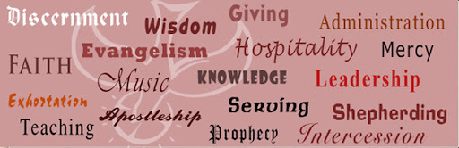Workshop on Our Charisms (Gifts of God) - May 25th 9:00 A.M. to 4:30 P.M. – Our Lady of Grace Monastery - Fr. Frank Pellerin, A.S.C. will speak on charisms in salvation history and our connectedness with our charisms, to salvation history. Cathy MacDougall will of the various charisms in the life of the Saints. Fr. Albert MacPherson, O.S.A. will speak on the charism of healing during the Healing Mass, at 2:30 P.M. Lunch is provided. Registration fee will be $25.00.